See YouTube videos.
See book..

Video:

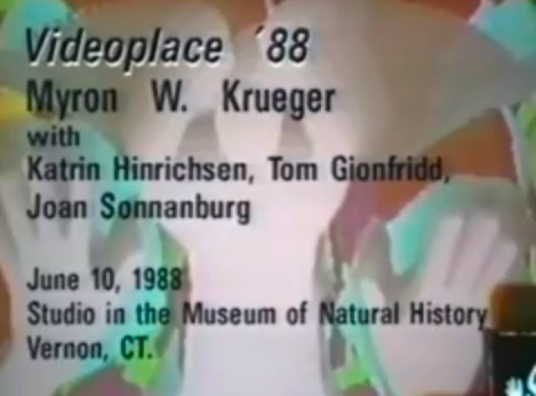

Shadows interacting

Scale

links between art shadow play (Schonewolf) and Krueger

